תיק משתמש

The first page (Home page):

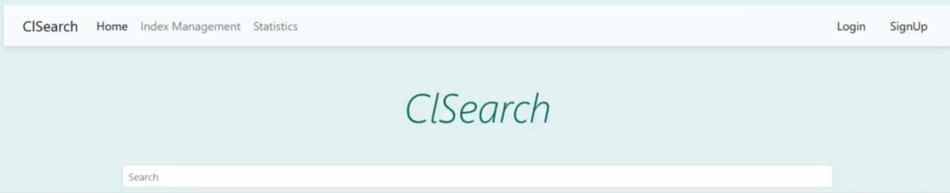

This is the first page, here you can insert a query to search something. You have 5 main buttons which are: Home, Index Management, Statistics, Login, and Signup. Each button opens a different page for different purposes.

Still on Home page:

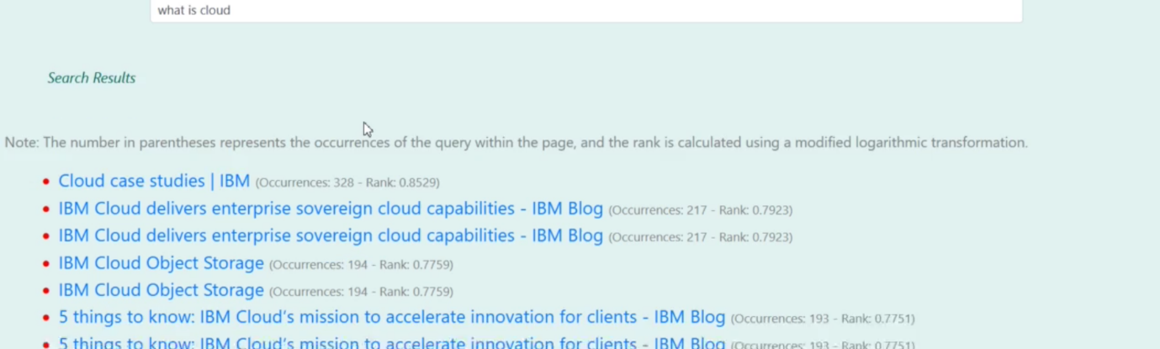

Here is an example of searching a query.

Index Management Page:

In this page you can see the content of the index, it’s a table which includes the word in the index, and its relevant links, in addition, there are buttons to manage the index: Add Word, Delete Word, and Add Link. Add Word button is to add a new word for the index (it allows to add a word only with it’s relevant links, you can’t add a word without link/links), Delete Word button is to delete a word (it deletes a whole row, hence, it delete the word with its relevant links), and Add Link button allows to add a link/link to an existing word.

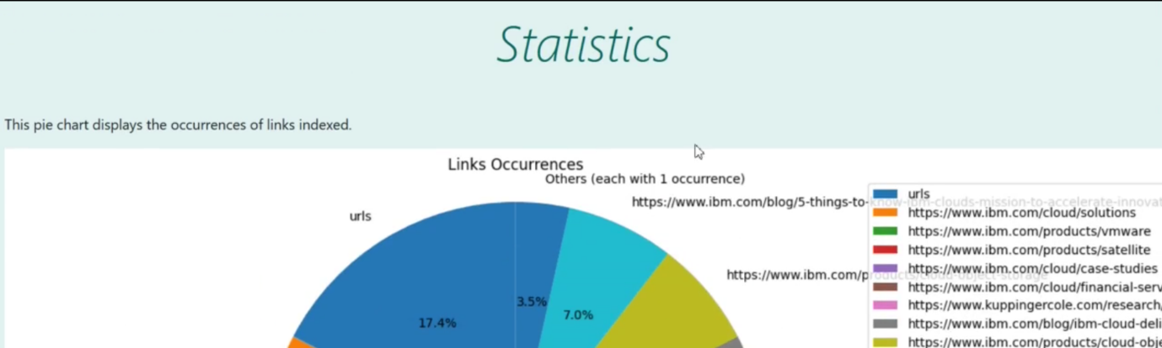Statistics Page:

This page shows a pie chart of the occurrences of each link in the index.

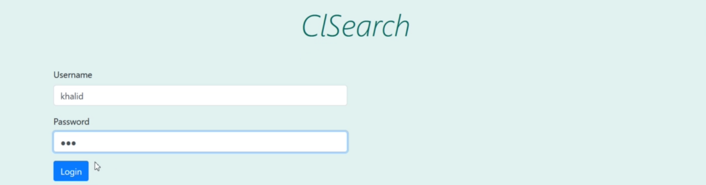Login Page:

This page allows the user to connect his user.

Signup page:

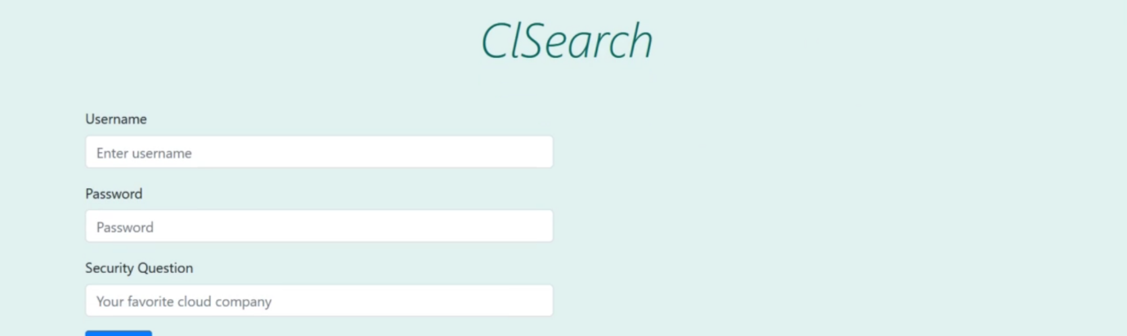

Here the user can signup a new account to the website.

User Statistics page:

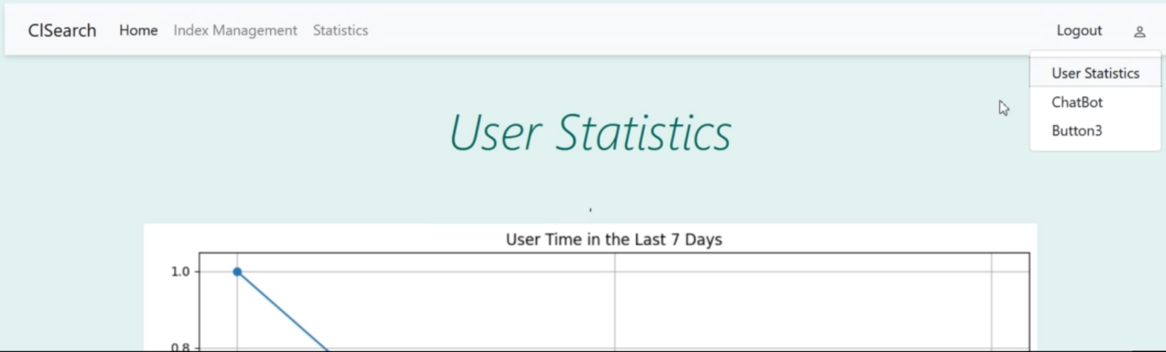

This page is reached only from the user (after login process), it shows statistics of the user, like the time spent by the user in the last 7 days, links of the user’s index.

Chatbot page:

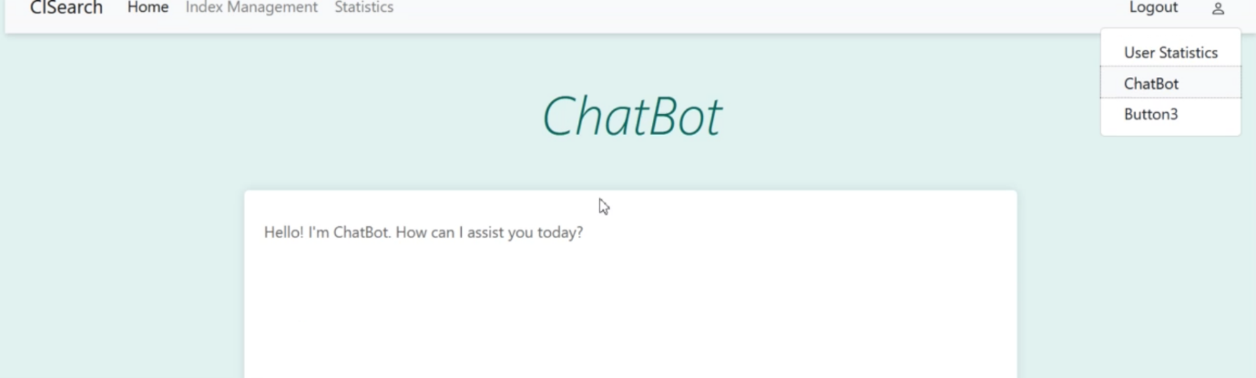

This is the Chatbot page, allows user to chat with the chatbot of the website, he can ask questions and get relevant answers.